Life Management 2.0 (IOS Version)

User Manual

Authors: Eric Rado

**Guest**

**Overview of App**

1 - Land on initial guest screen page

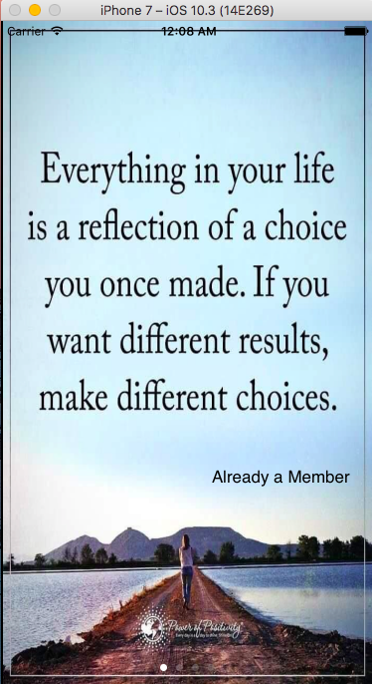

2 - Review the different emotions the app can bring out of you

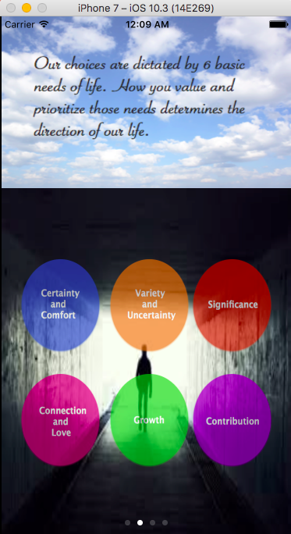

3 - More information and video which encourages to sign up. If convinced press sign up, which takes you to the signup page

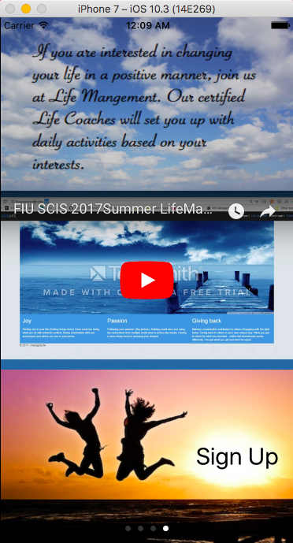

4 - In the registration form, fill out the fields then click “Register” to become a new user of Life Management

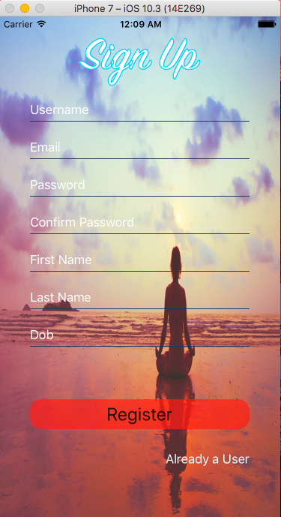

**User**

**Activity Selection**

1 - User selects two activities that brings joys out of him/her

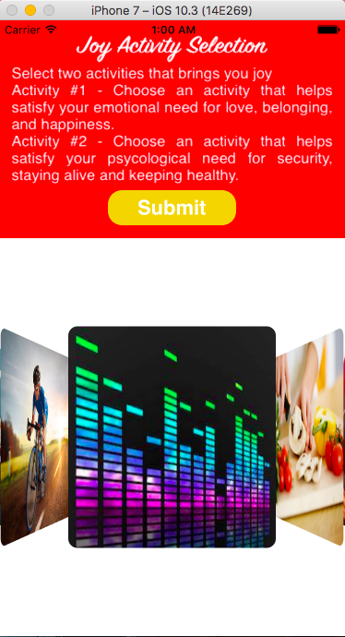

2 - Select two activities that brings out passion

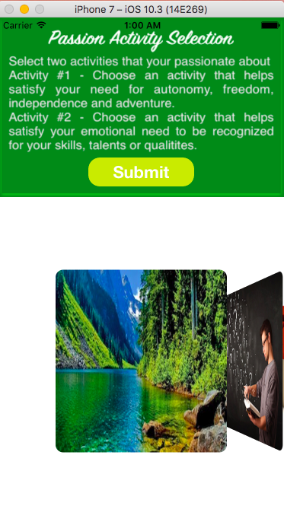

3 - Select two activities that brings out contribution

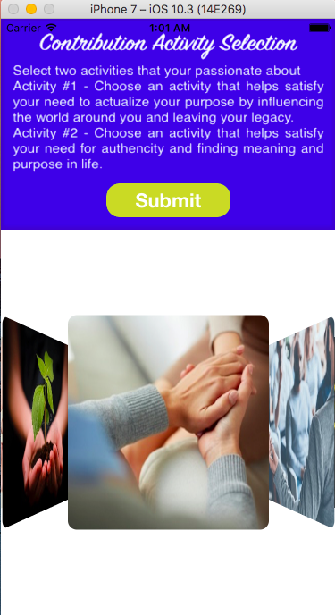

4 - Set the target points the user will try to achieve during the sprint cycle for each activity

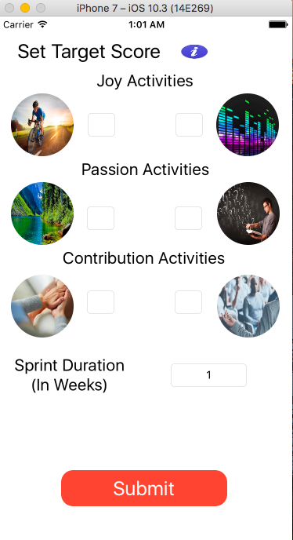

**Sign In**

1 - User can enter their username and password to login into their account

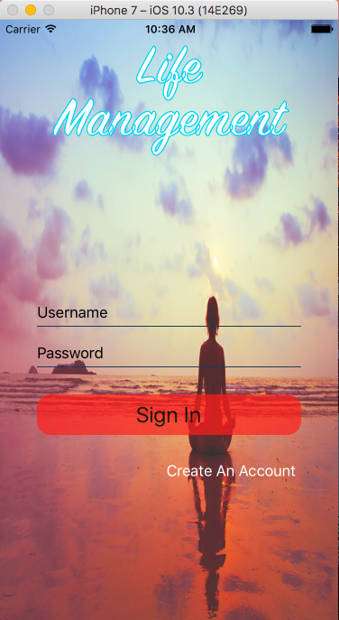

**Dashboard Overview**

1 - Once a user signs in they are redirected to their activity progress dashboard

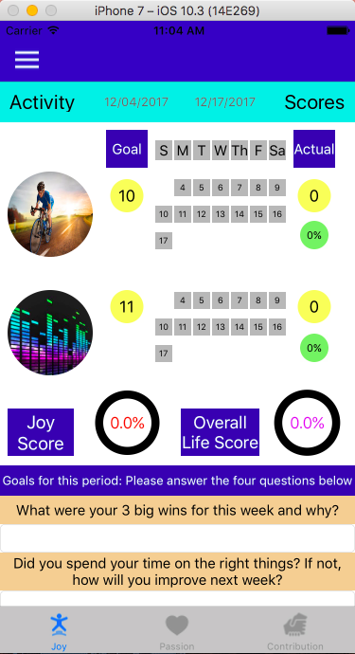

2 - A user can update their activity progress by clicking on a day button in which they engaged in the activity selected. The gray button will turn green to indicate the change.

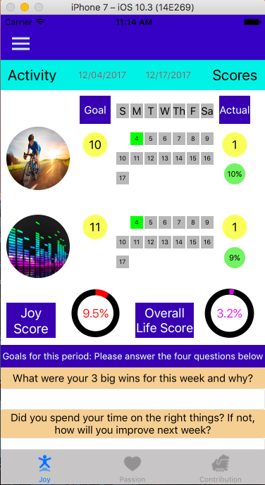

3- Update goals for the current sprint by clicking submit

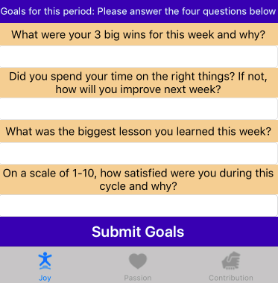

4- If a user wants to see his/her other activities that bring out different emotions click on any of the tabs below

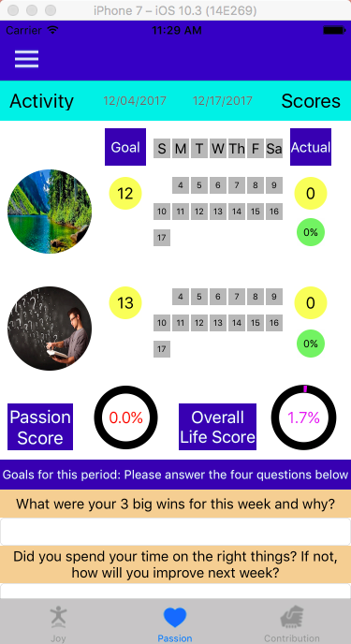

5 - Clicking on the dropdown button gives the user a variety of action they can take

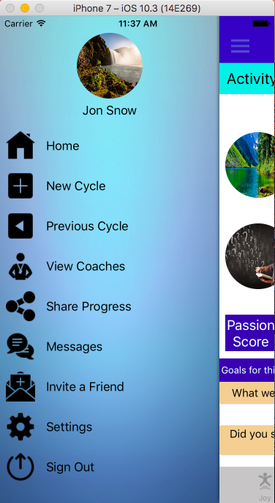

**Previous Cycles**

1 - On the side menu click “Previous Cycle”

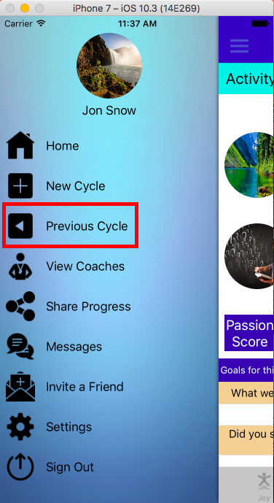

2 - Look through all the previous cycles then select one which the user wants to view more information

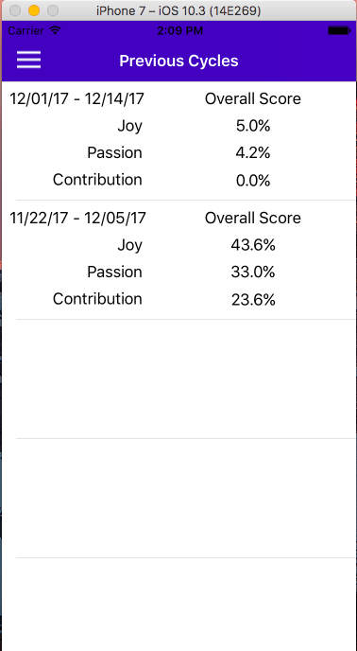

3 - Once there done looking through the information click on the back button

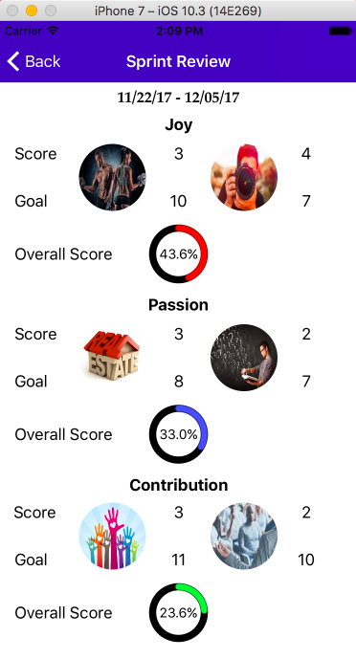

**View Coach List**

1 - On the side menu click “View Coaches”

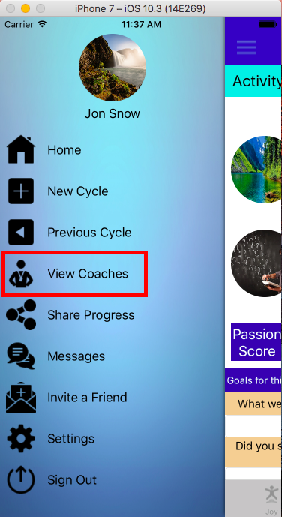

2 - A list of coaches which a user can chat with is displayed

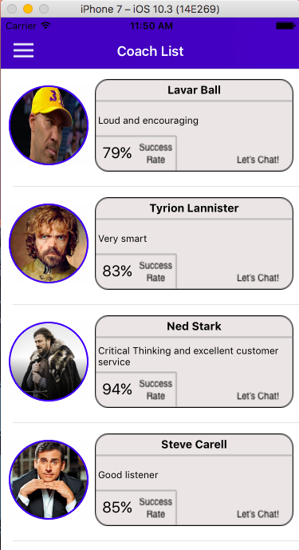

**Start a New Cycle**

1 - On the side menu click “New Cycle”

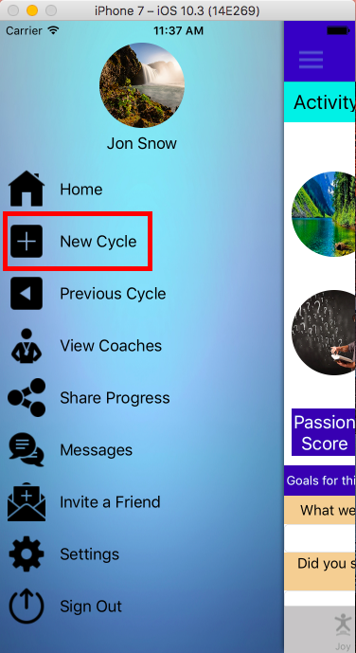

2 - Select activities for the three different emotions

3 - Set target scores for each of the selected activities and set the duration of the sprint

**Upload a User Image**

1 - On the side menu click “Settings”

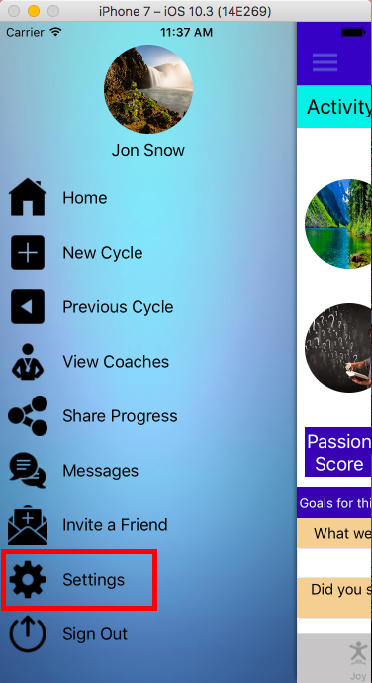

2 - Click on the camera icon

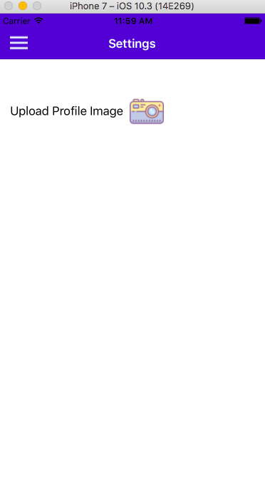

3 - Select an image to upload as user profile picture

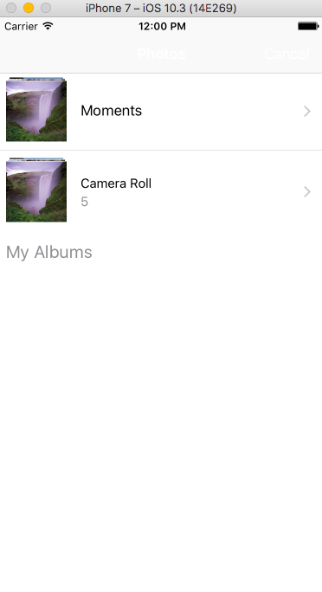

**Chat with a Coach**

1 - On the side menu click “Messages”

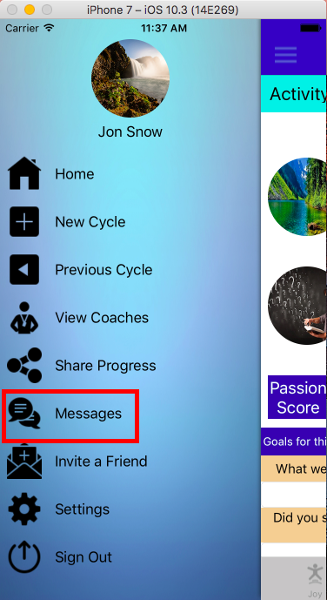

2 - Click on the conversation user wants to engage in

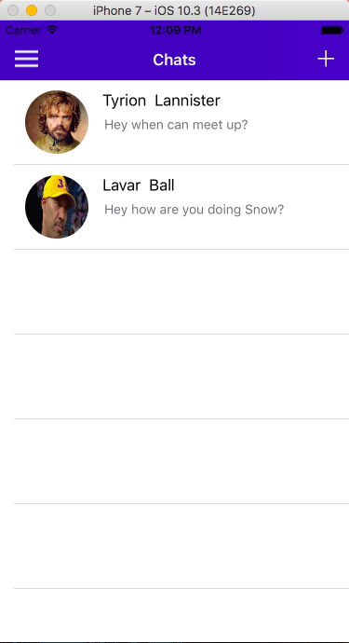

3 - Type a message then press send

